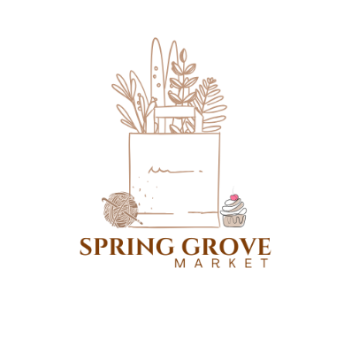
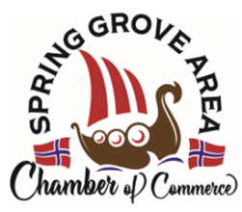
Simple Living Farmers’ Market
Spring Grove Market
2025 Vendor Application Form
Rules and regulations of the Spring Grove Market are in the bylaws. Please read them as there are requirements for each vendor to fulfill. All vendors are responsible for getting applicable product license(s), a sales tax identification number (as needed), Cottage Food Producer certificate/license (as needed), and paying their own sales tax (when appropriate).
This form must be filled out completely, signed, and fee paid prior to participating in the market.
Fees: $15/week, $45/season (weekly fees count toward the season fee)
Mail the form and fee to SG Area Chamber of Commerce, PO Box 452, Spring Grove, MN 55974. Or you may bring the form and fee to your first market attendance.
NAME
BUSINESS NAME
if an official business
STREET
CITY, STATE ZIP
EMAIL
CELL NUMBER
HOME NUMBER
optional
SALES TAX ID #
if required
COTTAGE FOOD PRODUCER REGIS #
if required
TYPES OF PRODUCTS  (check all that apply) | ❒fresh produce ❒ flowers / plants ❒baked goods ❒canned foods / preserves  ❒honey / syrup ❒meat / eggs ❒crafts / artisan works ❒service / product rep  ❒other __________________________________
YOUTH | grade-level just completed:  **ages 14 and under need adult present  **fees waived for youth booths, please still turn in a form to the Chamber
Amount paid | ❒cash  ❒check | Date paid

I, the undersigned, agree with and will abide by the rules and regulations of the Spring Grove Market. I will be responsible for my products as set forth in the rules and regulations. I will provide my own table and booth needs and will clean up my area at the end of the market each time.
Signature | Date

